Report Tips – Mailing Lists by Department/Major

Description: Displays admitted students for the current term categorized by college and department. The list can be downloaded into Excel for modification.

Accessing the Report: Log into My UNIverse, select the Reporting tab. Click the Data Warehouse Reports link. On the DDDH Home tab, click the Mailing Lists by Department/Major link in the Reports pagelet.

Example:

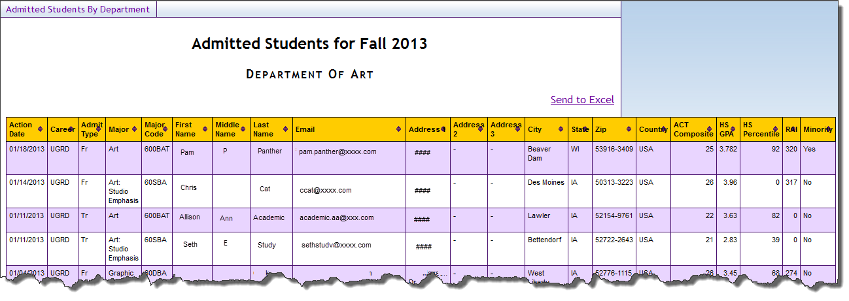

Tips:
- To sort by column, click the column header
- The data displayed shows active admits. Scroll to the bottom to view the “Data as of date”
- Use the Send to Excel link in the upper right corner to download this report to Excel

Troubleshooting
- If you experience internet browser issues, try reloading the page (F5 or Refresh/Reload button on the browser toolbar). You may also clear your internet cache (SHIFT+CONTROL+DELETE or Tools, Options).
- If you receive a message stating Access is Restricted, contact Institutional Research.
- My UNIverse times out after 20 minutes, it may be necessary to click back on the Reporting tab to avoid the time out.

